Researching on Roguelike popularity

* From the research I have taken from the video [1] from Extra Credits. I have found that the popularity of roguelikes has increased as designers have alleviated the disadvantage of the time it takes to understand how to play the game.
* For this I research, I will be looking in Steam, to look at modern roguelike games and to take note of the way designers have put a spin on roguelikes

[2] Monolith – a shoot-em-up Roguelike – instead of turn based its real time instead. The levels for this are also in a small box, which contain a variety of enemies and obstacles, rewards to choose from for this run and players can choose which route to take as it has branching paths.

[3] Don’t Starve: Reign of Giants – Sandbox, Crafting roguelike – instead of random dungeon generation it is instead a sandbox so players have more to explore and they have changed non modal gameplay by having the crafting mechanic so that the players can make items out of the materials they pick up throughout the game, which is suitable to the theme.

[4] Slay the Spire – Card game, Strategy Roguelike – Instead of hack and slash gameplay, the players choose to play with cards where they strategize how they attack and defeat enemies. This game also has branching paths too.

[5] Crypt of the Necro Dancer – A Rhythm Dungeon Roguelike - Rhythm dungeon crawler roguelike where turn based gameplay is tweaked so that players must attack, defend and move to the beat of the music. This game gives you 3 lives until perma death but lives can be obtained throughout the game. It also gives you a map of the generated area. The player must go through different generated maps until coming to a final boss as they go through the tunnel holes. Good tension and release. Story based game so it gives players time to breathe

[6] Downwell – Vertical Platformer Roguelike – Instead of the classic platformer, it is vertical and so the player character is always falling, making for fast paced gameplay. For random dungeon generation, the game has different caverns/levels after a certain amount of time, which is good because it offers the player a breather from their constant engagement and focus on the game. There are also side rooms that show up giving the player time to breathe before they continue. Having levels also gives the player the objective of get to the bottom which gives replayability as players have a goal to work towards. The objective isn’t lost when the player dies.

[7] Super House of Dead Ninjas – Platformer Roguelike – fast paced platformer which gives you 5 lives as there are easy mistakes to make so it is forgiving. It relies on twitch gameplay as it removes turn based gameplay completely and players must react quickly to defeating enemies. There is also a timer to the game so the players are given that build up of tension to defeat as many enemies as they can and go through the map as quickly as they can. This game takes away the harsh mechanics of limited resources as there are time pickups giving the player a buffer of 2 seconds on the clock extra for every pickup and those are generously put across the map as it is an endless runner. The only thing making the players lose is time.

[8]

Remember this part of notes when mixing up the 8 elements of a roguelike:

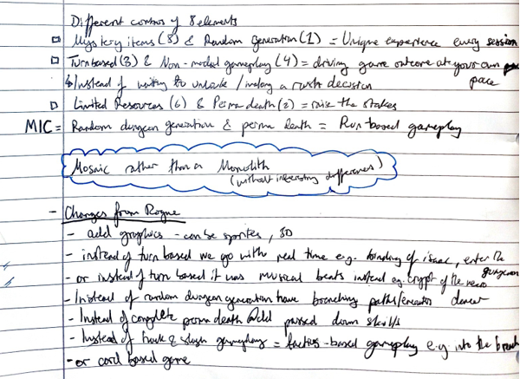

References

[1] Extra Credits (2014). *Roguelike Returns - How to Revive a Genre - Extra Credits*. [video] Available at: <https://www.youtube.com/watch?v=gk8ZknjYmek> [Accessed 27 Sep. 2019].

[2] <https://store.steampowered.com/search/?snr=1_4_4__12&term=roguelike>

[3] <https://store.steampowered.com/app/282470/Dont_Starve_Reign_of_Giants/?snr=1_7_7_151_150_1>

[4] <https://store.steampowered.com/app/646570/Slay_the_Spire/?snr=1_7_7_151_150_1>

[5] <https://store.steampowered.com/app/247080/Crypt_of_the_NecroDancer/?snr=1_7_7_151_150_1>

[6] <https://store.steampowered.com/app/360740/Downwell/?snr=1_7_7_151_150_1>

[7] <https://store.steampowered.com/app/224820/Super_House_of_Dead_Ninjas/?snr=1_7_7_151_150_1>

[8]